

# Institute of Technology of Cambodia

|  |  |  |  |  |  |  |  |  |
| --- | --- | --- | --- | --- | --- | --- | --- | --- |
|  | | | | | | | | |
|  | | Project Report-Group 6 | | | | |  | |
|  |  | | | | | | |  |
|  | | | |  |  | | | |
|  | | | | GIC-I3 |  | | | |
|  | | | | Deadline: 11 July 2021— Course: Combinational And  Sequential Logic I —Lecturer: Mr. Heng Rathpisey 2020~2021 |  | | | |
|  | | |  | | |  | | |

Contents

# Introduction: ………………………………4

# Function and Features: …………….……4

# Truth Table: ……………………….………..5

# Logic Function: ……………………………6

# Implementation: ……………………….7-11

# Result: …………………..…………………..12

# Conclusion: ………………………………..12

# Team Work

|  |  |
| --- | --- |
| NAME | ID |
| 1.Chheng AFA | e20180106 |
| 2.Hourt Keomly | e20180325 |
| 3.Hun Ravit | e20180328 |
| 4.Keo Linna | e20180368 |
| 5.Keun Sreyleav | e20180377 |

# Introduction

We have been assigned with the development of the circuit mini project in subject Combinational and sequential logic. The aim of this project is to build a simple timing with similar function as digital clock. This project includes function Stopwatch, Timer, Simple watch, initializer, Alarm clock and Setting mode.

# Function and Features

* Stop watch: the system can count time up to 24 hours and reset.
* Timer: the system can count down the time with an initialized value set by an initializer and reset.
* Simple watch: the system will work as a simple digital clock that could be reset with an initialized values and reset.
* Initializer: a mechanism with 2 buttons, an increment, and decrement button to set a value and reset for each correspond digits.
* Alarm clock: the system can set an alarm by an initialized value with blinking led as result.
* Setting mode: a mechanism that will display the watch each of the feature modes, simple watch, timer, stopwatch, alarm setting. It is a simple button will change mode.

# Truth Table

Counter 0-2

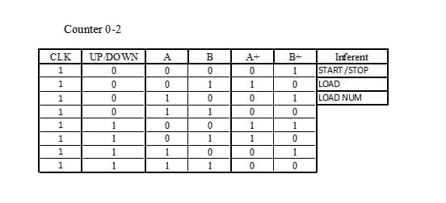

Counter 0-5

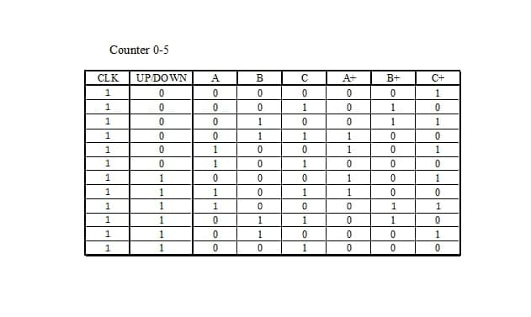

Counter 0-9

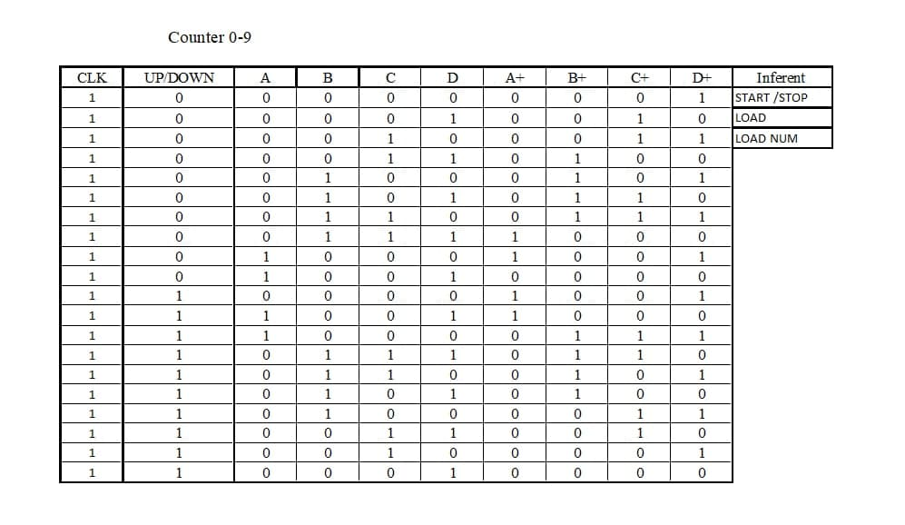

# Logic Function

* Counter 0-2:

K(Q0) = 1

K(Q1) = 1

J(Q0) = Q’1

J(Q1) = Q0

* Counter 0-5

JK(Q0) = 1

K(Q1) = down ⨁ Q0

J(Q1) = (Q2+Q0’+ down)’ + Q2Q0’ down

K(Q2) = K(Q1)

J(Q2) = (Q0’+ Q1’ + down)’ + Q0’Q1’ down

* Counter 0-9

let

D = up/ down

A1 = D ⨁ Q0

A2 = D ⨁ Q1

A3 = D ⨁ Q2

JK(Q0) = 1

K(Q1) = A1

J(Q1) = A1[ (Q3’. D’) + (D (A3.Q3’)’)]

K(Q2) = A1.A2

J(Q2) = A1[ (A2. D’) + (D.Q3’)]

K(Q3) = A1

J(Q3) = A1A3

# Implementation

* **Counter 0-2**: it used JK flip flop to count number from 0 to 2 is loop again and again and it have function clear and load initial. About load initial we need to input the default value and then we click button load it will load to present state in JK flip flop and we can continue count it normal.
* **Counter 0-5**: it creates from JK flip flop and multiplexer. JK flip flop is used to counter number from 0 to 5 by using clock and logic function to input j and k and it have more input. About multiplexer is used to help set default in JK flip flop.
* Input down it used to control circuit to counter down when it is in number 1 But when it in number 0 it will count up.
* Input clear it used to clear all number in JK flip flop it connects to reset in JK flip flop.
* Input load it used to load JK flip flop by first it clears all number it JK flip flop and then it sends the load number that we set to present state in each JK flip flop.
* Input load number is used to set default values that we need to set.
* First, we need to connect it with clock and then it will start counter. It counts up and down follow to the input button down when it equal 1 it will down and if it is 0 it will up. About the button clears we used to clears when we want to start counter again or we want to start from zero. About the load and load number. When we want to set the initial value, we need to send number in load number and then we need to select on load input it will load to the JK and display or output that we can see. About the increase we used to increase when we count from 0-5, we need to increase 1. But it used only it time or clock. It this circuit it is not useful.
* **Counter 0-9**: It is similarly to counter 0-5 but it used more JK- flip flop and it have difficult to write logic function than counter 0-5. It has input the same of counter 0-5 and the process of it is it can counter from number 0 to 9 it can counter down when we set button input down number 1 and about the clock, we need to connect all time. One more thing on clears it used to clears all the JK flip flop and start new counter. About load and load number. first, we need to send default number that we want to display before we prese on button load. About load it will to clear all old data and set the default value to each JK flip flop.
* **Counter 0-59**: It is built from combine 0-5 up down and 0-9 up down sub circuit.
* Sub circuit 0-5 up down: it is created from 3 JK flip flop, logic functions and multiplexer.
* Input down: When it 1 it will count down from 5 to 0 and when it 0, it will count up. We use logic function and input it in J and K on X1 and X0.
* Input clock: It is the important input to process this system.
* Input clear: It use for clear all number in JK flip flop. It uses logic function and input in its Asynchronous Reset of JK flip flop (X0, X1, X3).
* Input load: It use for load number that user has input in load num. It uses logic function, multiplexer and input in its Asynchronous Reset of JK flip flop (X0, X1, X3).
* Input load num: It use for set number 0-5. It uses multiplexer and input it in Preset of JK flip flop (X0, X1, X3).
* Output x0, x1, x2, x3: It get from Q of JK flip flop (X0, X1, X2) and x3 get from input fix 0.
* Output inc: It get from logic function. Inc is important in next circuit that use it to combine.
* Sub circuit 0-9 up down: This is created similar to circuit 0-5 counter up down. The different is we use 4 JK flip flop.
* For the uses of input and output in circuit 0-5 and 0-9 up down is the same.
* Circuit 0-59 up down: Other’s input is the same like sub circuit above. But the input clock of sub circuit 0-5 up down is inc(increate) that is the output of sub circuit 0-9 up down. This connection use for when counter 0-9 back to start from 0 it increases number of counter 0-5.
* **counter 24:** it used to display number from 0-24. Circuit counter 0-24 it combines from counter 0-2 and counter 0-9. The two of loop in this circuit we used 0-9 for counting and the last we loop it only from 0-4 and it will increase or restart again.
* **Clock all function**: About clock all function is it used to combined function counter 0-59 and counter 0-24 to create a watch that have second, minute and hour.
* Second is insert from counter 0-59 and it counter 0-59 is connect to clock and when it back to start from 0 it increases number of minutes. It works again and again until we stop it.
* Minute is insert from counter 0-59 the same of Second but the clock of it is connect to increase from second when second count from 0-59 it will clock one time and minute have increase the same. Increase it minute it used to increase hour in function.
* Hour is insert from counter 0-24. Clock of it is connect to the increase from minute. It counters from 0 to 24 when it full it will start from time 00 again.
* The button than we used in this function is:
* down is used to counter down
* Clear is used to clear when we want to start again
* Load is used to load number
* load number is used for set default value of hour, minute, and second.
* It can be used more function that we need by we just connect to the clock it will start counter and we can counter up and down by set the value of input down. When we want to start again, we can press clears button it clear and start count normal. Set default is we need to set load number and then we press the load button input to load number that we already set. If we do not set it is normal but number, we load it zero.
* **Timer:** the system can count down the time with an initialized value set by an initialized and reset. **Clock function** is the part of Timer that we use to build Timer because it is similar to Timer so we use some function from **Clock function** to build Timer like 0-59 counter and 0-24 counter.
* Timer: About Timer is it used to combined function counter 0-59 and counter 0-24 to create a watch that have second, minute and hour. That is similar to **Clock function**
* Second is insert from counter 0-59 and it counter 0-59 is connect to clock and when it back to start from 0 it increases number of minutes. It works again and again until we stop it.
* Minute is insert from counter 0-59 the same of Second but the clock of it is connect to increase from second when second count from 0-59 it will clock one time and minute have increase the same. Increase it minute it used to increase hour in function.
* Hour is insert from counter 0-24. Clock of it is connect to the increase from minute. It counters from 0 to 24 when it full it will start from time 00 again.
* The button than we used in this function is:
* Cancel is used to clear when we want to start again
* Initial is used to set default value
* Load is used to load number
* Load number is used for set default value of hour, minute, and second.
* **Stop Watch:** We use clock function
* Clock All Function: About clock all function is it used to combined function counter 0-59 and counter 0-24 to create a watch that have second, minute and hour.
* Second is insert from counter 0-59 and it counter 0-59 is connect to clock and when it back to start from 0 it increases number of minutes. It works again and again until we stop it.
* Minute is insert from counter 0-59 the same of Second but the clock of it is connect to increase from second when second count from 0-59 it will clock one time and minute have increase the same. Increase it minute it used to increase hour in function.
* Hour is insert from counter 0-24. Clock of it is connect to the increase from minute. It counters from 0 to 24 when it full it will start from time 00 again.
* The button than we used in this Stopwatch is:
* Input down: we set it as 0. Because stop watch it always up.
* Reset: we set it as a button that can clear it back to 00h 00m 00s
* Start/Stop: When it 1 it will start counting from 0s up to minute up to hours. When it 0 it will stop counting.
* **Alarm Clock:** it is a system time that it alarms when you set default time depend on you want to. And we use **clock all function** to make alarm clock.

Then it is the step of the process it.

* And after we insert it.
* Set Alarm Clock: We just set the default that have 4 bits inputs to connect to HexDisplay and total there are six HexDisplays. And two of six represent to Hour, Minute, Second.
* Continuously, making a comparison between clock and the set alarm clock. We use XnorGate to compare. Then Second alarm and Second clock, Minute alarm and Minute clock, Hour alarm and Hour clock. Then compare XnorGate of each Hour, Minute and Second use ANDGate.
* To identify it alarm, I use light bulb because it displays just a bit and for my alarm clock display 4 bit so I make compare again. I use ANDGate that need 4 bits input and a bit output.

Counter 0-2

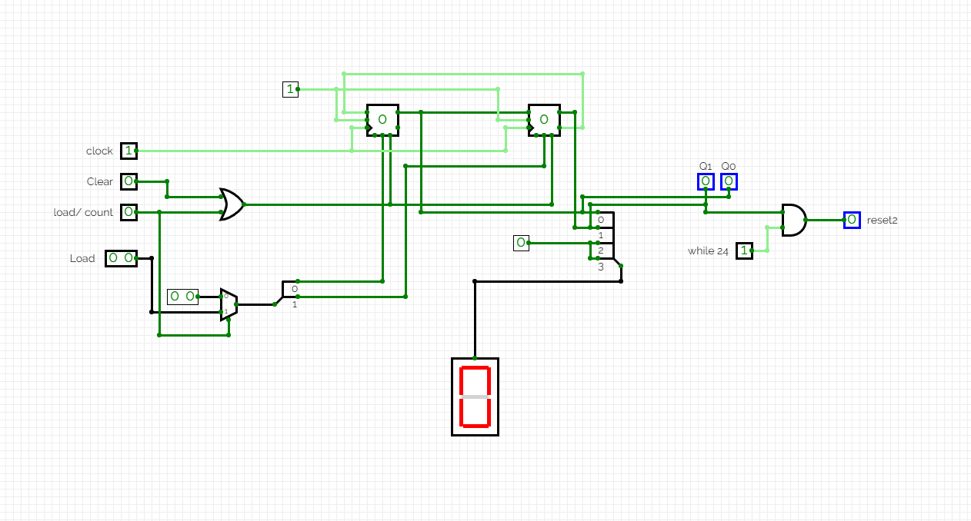

**Counter 0-5**

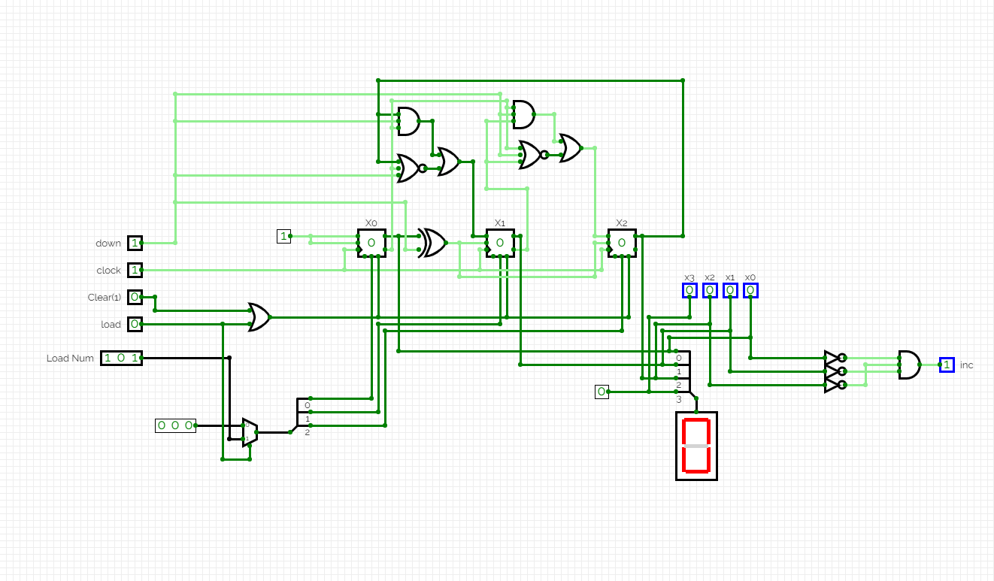

**Counter 0-9**

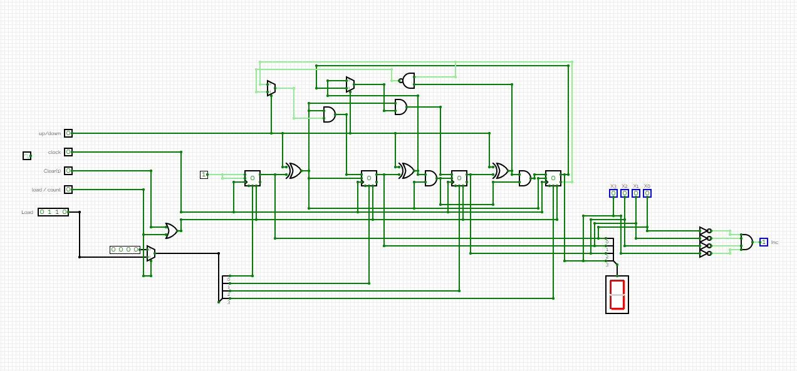

**Counter 0-24**

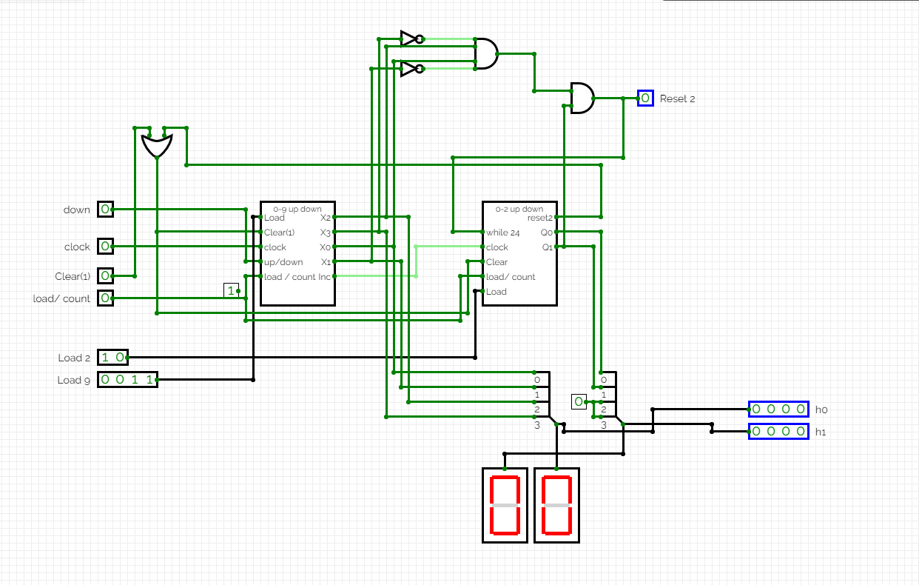

**Counter 0-59**

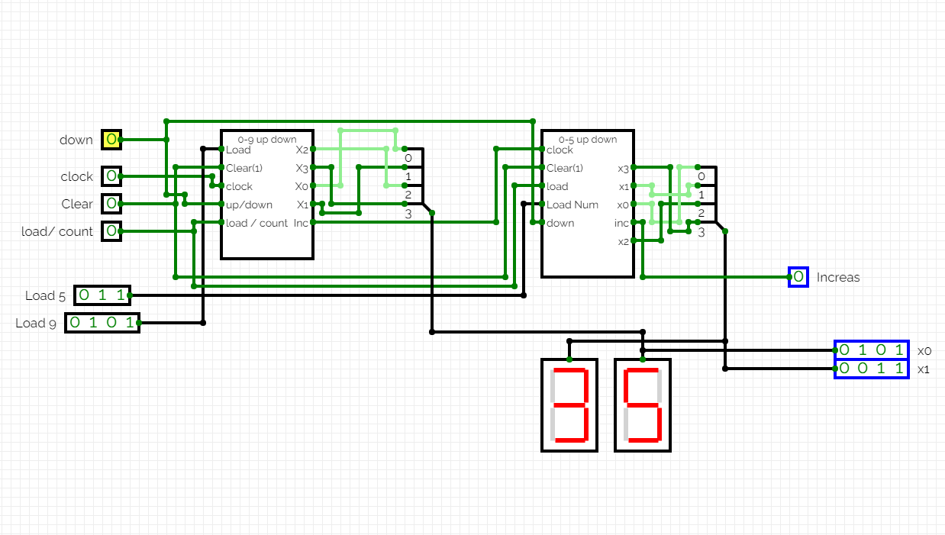

**Stop watch**

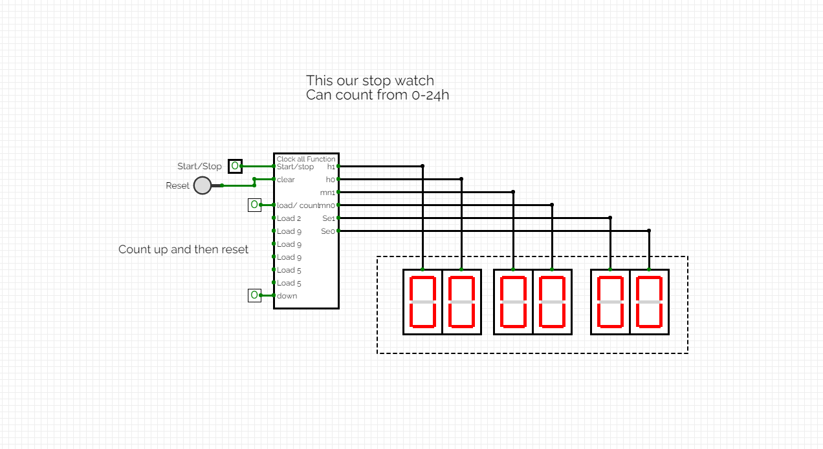

**TIMER**

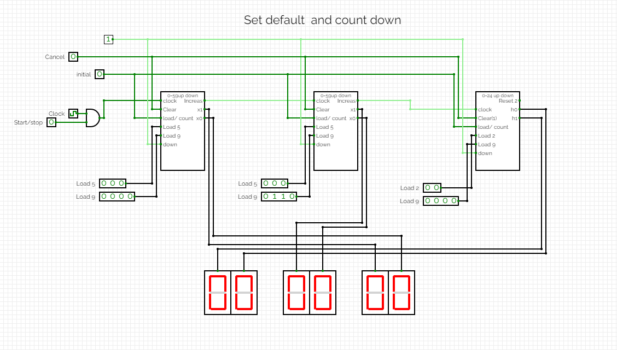

**CLOCK FUNCTION**

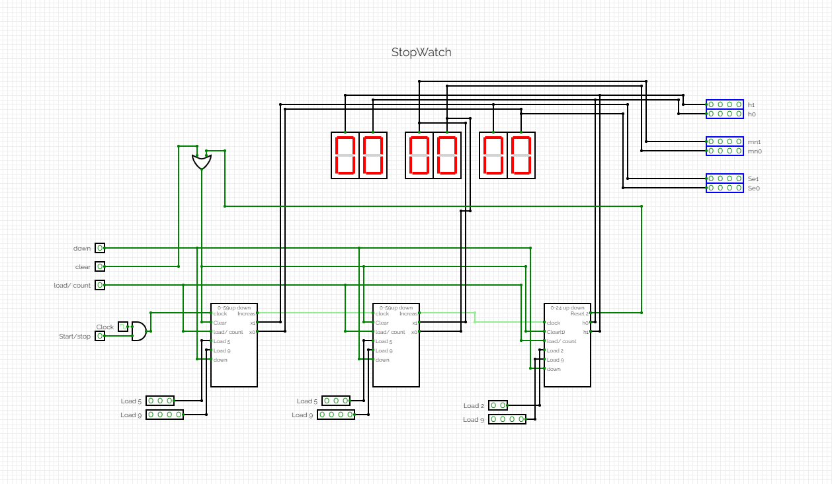

# Result

As the result we have completed all of the project plan as assigned by the teacher. But one of in project is the Timer, we have some problems when we count down. It not truly because it counts more than 60 seconds.

# Conclusion

In conclusion, after completing this project as a team we have learned the power of teamwork and we have a better understanding of the functions that are being used in this project such as JK flipflop, multiplexer and combine it to a big circuit from part of circuit. We have also learnt about research and improve soft skill and know to learn by ourself and team.